Tab 1

Predicting Post-Myocardial Infarction Complications Using Machine Learning
Team 3A: Yuanfei Chen, Han Pham, Neha Kolagatla, Qinyi Ding, Yuqi Zhou, Spencer Cao

1. Executive Summary
Myocardial infarction (MI) presents a pressing challenge for hospitals, where determining which patients are likely to develop severe in-hospital complications must often occur within minutes of admission. The purpose of this project is to design a machine learning model capable of predicting major complications using only admission-time features, such as variables that clinicians have immediate access to upon patient arrival. Using a dataset of 1,700 patient cases, 124 variables, and a binary target outcome (“Major_Complication”), we developed and evaluated two different models: Decision Trees and Random Forests. Since our dataset is highly imbalanced, we experimented with four different machine learning strategies such as post pruning with cross validation, SMOTE, feature selection, and Random Forest to determine which approach delivers the strongest gains in accuracy and recall (sensitivity). At the beginning of our research and test, a simple model without data preprocessing and feature selection resulted in biased detection of true negatives. However, with further tests, we achieved the best model that increased the detection of true major complication cases while maintaining acceptable accuracy and recall values. Next, we provide a more detailed overview of our machine learning development process.

2. Introduction

2.1 Our business idea and why it’s important

Myocardial infarction (MI) remains a leading cause of morbidity and mortality, and early identification of patients at risk for severe in-hospital complications remains a key challenge in clinical care. When patients arrive at the emergency department with MI, clinicians must rapidly assess their risk of developing severe in-hospital complications such as cardiogenic shock, acute heart failure, pulmonary edema, recurrent MI, or life-threatening arrhythmias. In certain cases, hospital resources such as ICU beds, cardiac monitoring equipment, and specialized staffing are limited, but early and accurate risk classification is vital for optimizing care and preventing major complications. Therefore, with this issue in mind, our project aims to use myocardial-risk patient data to predict whether individuals will experience major complications that could lead to major complications.

2.2 Data Source

Our MI raw data is publicly available and can be found on both the UCI Machine Learning Repository (link 1) or the University of Leicester’s database (link 2). It was originally collected at the Krasnoyarsk Interdistrict Clinical Hospital and compiled by Krasnoyarsk State Medical University for use in research studies headed by S.E. Golonvenkin. We planned to use the data to build a machine learning model that predicts our selected target variable, a binary indicator called “Major_Complication,” which identifies whether a patient is at high risk of experiencing a major in-hospital event based solely on admission-time data. The target variable represents possible events such as cardiogenic shock, acute heart failure, pulmonary edema, recurrent MI, or life-threatening arrhythmias. By doing this, we believe that we’ll be capable of capturing clinically meaningful deterioration, supporting early risk stratification, and directly informing hospital decisions related to ICU monitoring, staffing, and emergency resource allocation.

3. Data summary, description, visualization.

3.1 Structure and Cleaning
The dataset contains 124 columns and 1,700 patient instances. First, we dropped unnecessary columns, such as ‘ID’, from our dataset. Then, we identified total missing values by using the .isnull().sum() parameter, and discovered that there were 15,974 missing values. Next, in order to efficiently use filtering feature selection to clean the data, we identified the column value types for all columns. Once we identified column value types, we handled missing values by using median imputation for numerical features and mode imputation for categorical ones. Because the dataset includes numerous laboratory measurements and physiological indicators, thorough preprocessing was crucial to reduce noise and ensure the stability and reliability of the resulting models.
Next, we renamed and isolated the target variable (‘LET_IT’) from the independent variables (features) by creating separate dataframes. We then applied a standard train-test split to prepare the data for our later modeling workflow, which incorporated filter-based feature selection followed by a Decision Tree classification model with post-pruning and 5-fold cross-validation.

3.2 Exploratory Data Analysis Visualization / Patterns
Our exploratory analysis provides important initial insights into the dataset before building our prediction model, particularly regarding age distribution and target class balance. As shown in the Age Distribution box plot, the patient population follows an approximately normal distribution but is skewed toward an older demographic, with the highest frequency occurring between ages 60 and 70. This suggests that the medical complications being studied are most prevalent among older adults, which aligns with standard clinical expectations and is further supported by the research article “Trends in Acute Myocardial Infarction by Race and Ethnicity” by Gloria C. Chi, which reports that the trend of patients with critical myocardial infarction have an average age of 69.2 years. From the box plot, there is a noticeable drop-off in patients younger than 40 and older than 85, indicating that these extreme age groups are underrepresented in the cohort.
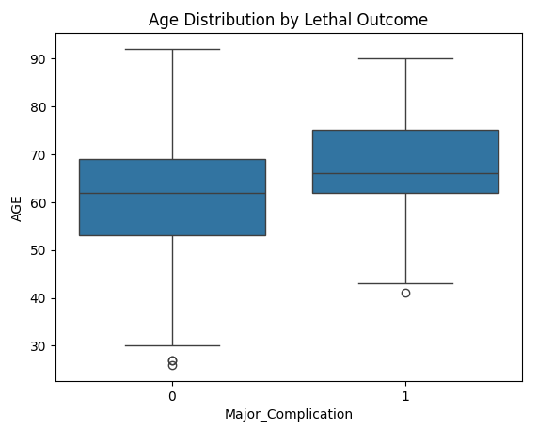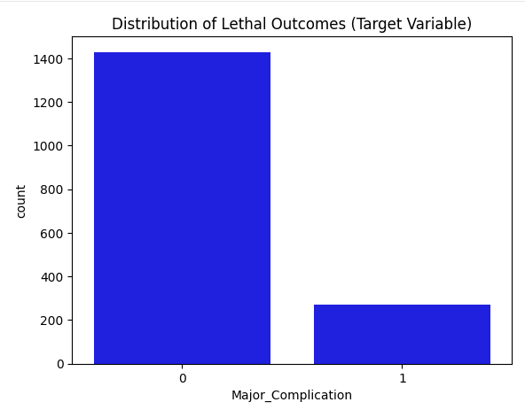
Simultaneously, the Distribution of Lethal Outcomes (Target Variable) bar chart highlights a severe class imbalance. The majority of patients who experience no major or lethal complications significantly outnumber the cases of patients who do. Specifically, the “no lethal outcome” class approaches 1500 instances, while the "lethal outcome" cases appear to be fewer than 200. This stark imbalance (roughly an 8:1 ratio) poses a significant challenge for modeling; standard algorithms may prioritize accuracy on the majority class at the expense of detecting the minority "lethal outcome” cases. With this in mind, we approached our research and machine learning model development with the objective of addressing the class imbalance beforehand.

4. Analytical Approach

4.1 Model Selection
We used two primary procedures to create our machine learning model to predict major complications:
The First Approach:
- Use the filtering technique for feature selection to choose the best independent variables out of the 124 variables.
- Build a simple decision tree classification model to predict major complications.
- Apply post pruning with cross validation to increase accuracy and sensitivity.
- Finally apply SMOTE to resolve problems in imbalance within our medical data.
The Second Approach:
- Building another simple Decision Tree Classification model, but without prior filtering.
- Incorporate a Random Forest Classifier, a robust ensemble-based model, which will capture non-linear relationships across many features and handle imbalance in the data.

4.2 Reasoning for Approach 1 for Analysis
Our first analytical approach focuses on developing an interpretable model that aligns closely with typical clinical decision workflows. Since the dataset contains 124 variables, many of which are noisy, redundant, or weakly associated with the target, this approach emphasizes careful preprocessing and dimensionality reduction prior to model construction. We selected filtering for feature selection, which evaluates each feature individually using the mutual information statistical measure. Mutual information is computationally efficient and appropriate for high-dimensional medical data, because it can be used on any target type and feature type.
Once a refined subset of 15 relevant features was obtained, we used a Decision Tree classifier as our baseline model. Decision Trees offer a clear interpretation, which is essential in clinical settings where model transparency and the ability to justify predictions are especially important. However, decision trees are prone to overfitting, particularly in imbalanced datasets such as ours. To address this issue, we implemented post-pruning with cross-validation, which allows the model to remove branches that do not generalize well and improves predictive stability.
Additionally, our target variable is highly imbalanced, the model initially favored the majority “no major complication” class. To ensure the model became more sensitive to clinically meaningful minority cases, we applied SMOTE (Synthetic Minority Over-sampling Technique) at the final stage. SMOTE generates synthetic examples of the complication class, increasing the model’s ability to detect high-risk patients without excessively distorting the underlying distribution.

4.3 Reasoning for Approach 2 for Analysis
For our second attempt, we used our second approach which was to test whether a more complex, ensemble-based model could outperform Approach 1. Instead of performing early feature selection or post pruning, we began with a raw Decision Tree classifier to establish a baseline understanding of model behavior when given the full, high-dimensional dataset. This approach highlights how Decision Trees perform without external constraints and shows whether the model can naturally create meaningful feature splits even with the presence of noise.
Building on this, we incorporated a Random Forest classifier, which is known for its strong performance on structured tabular data and its robustness in handling non-linear feature interactions. The Random Forest Classifier trains many individual decision trees on random subsets of features and observations, then aggregates their predictions. Other benefits of using Random Forest is that it reduces variance, improves generalization, yields higher predictive accuracy, and inherently performs feature selection. Therefore, this makes Random Forests well-suited for the dataset of 124 clinical features.
Additionally, ensemble methods like Random Forests can partially mitigate class imbalance by exposing each tree to slightly different distributions of minority-class samples during training. Within python, this is done by setting the following parameter: class_weight = “balanced”. Although this does not fully eliminate imbalance issues, it often results in improved recall on the minority class compared with a single tree.

5. Benchmarking, Preprocessing, and Model Performance

5.1 Benchmark Comparisons
Our first benchmark is a baseline Decision Tree without preprocessing. It achieved approximately 76.471% overall accuracy. While predictive performance on low-risk MI patients (class 0) was strong, the model struggled with predicting high-risk MI patients (class 1), reaching only a 37% precision and an F1-score of 0.49. This suggests that the model is biased toward the majority class (low-risk patients) and performs poorly on the minority class(high-risk), and can have extremely dangerous consequences if we were to send high-risk MI patients we incorrectly identified as low risk home.
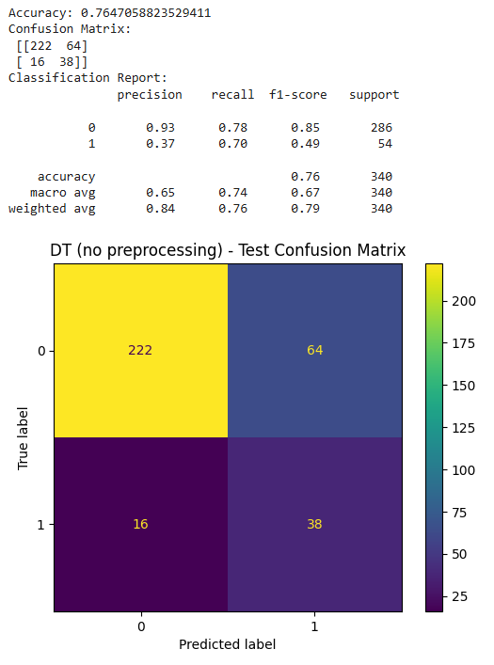
Additionally, the confusion matrix above confirms the class proportion: Class 0 accounts for approximately 84% of the data, while Class 1 represents 16% of the data. This further shows that our dataset, prior to preprocessing, is highly imbalanced.

For our second benchmark, we will be comparing our decision tree without preprocessing to our two approaches.
- Approach 1:
  - After performing a train-test split on the data we used filtering feature selection with mutual information to choose the top 15 significant independent variables to use out of the 124 variables.
  - Then we built a decision tree classification model to predict major complications along with applying post pruning with cross validation to increase accuracy and sensitivity.
Results:
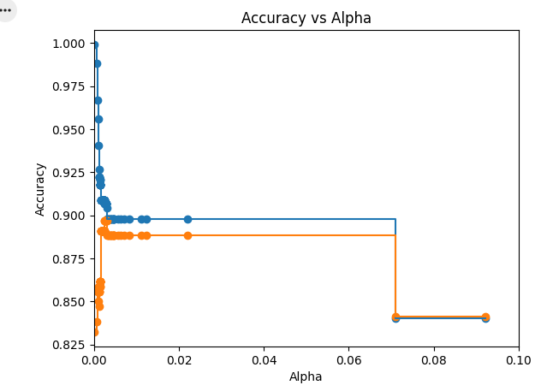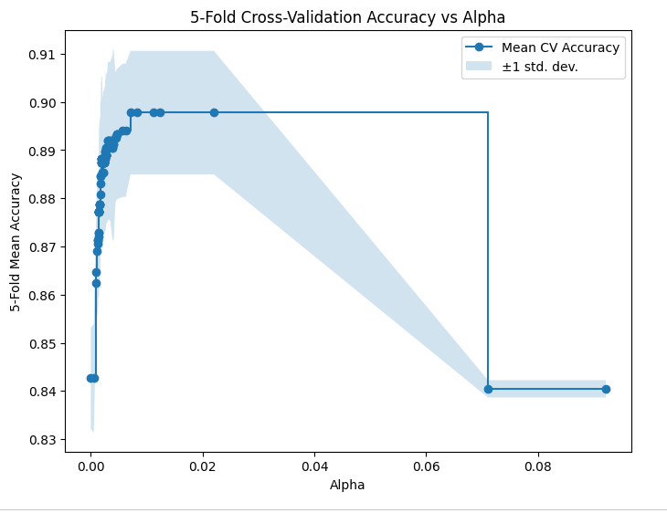
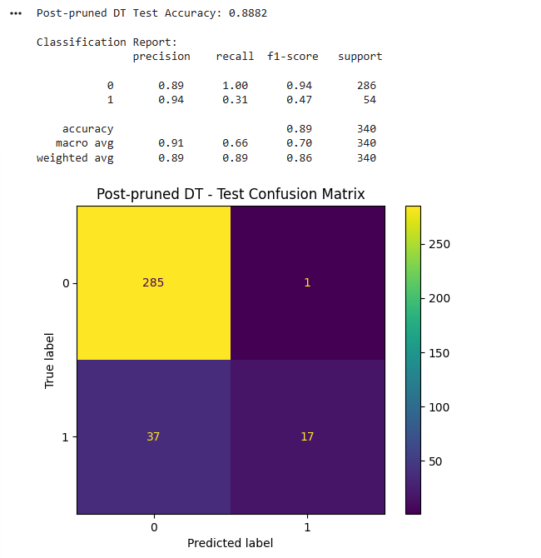

  - By comparing the original confusion matrix (without preprocessing) to the post-pruned model shown above, we see a substantial improvement in performance: overall accuracy increased from 76.47% to 88.82%. The class distribution remains the same but, now in the filtered model, Class 0 achieves a strong precision of 89% for identifying low-risk MI patients, while Class 1 reaches an even higher precision of 94% for identifying high-risk patients. However, an important concern persists, as the model continues to exhibit low recall for Class 1 (0.31), indicating that 69% of high-risk patients are missed / misclassified as low-risk despite its high precision.

  - To resolve the imbalance within our medical data, we implemented SMOTE:
Results:
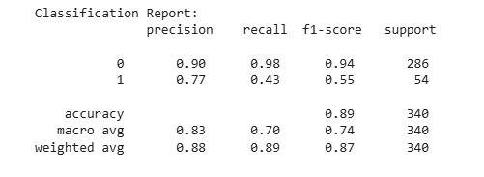
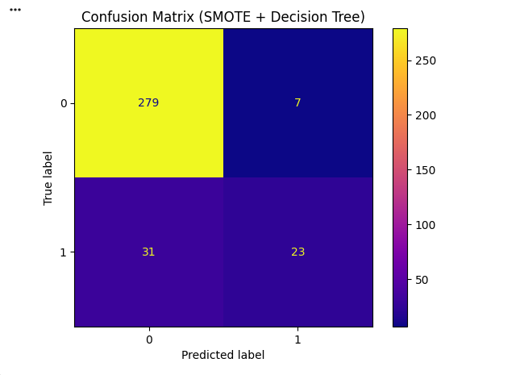
  - After applying SMOTE to resolve imbalance in the dataset and then training another Decision Tree, the model shows a different performance pattern compared to our model using post pruning and 5-fold cross validation:
    - The overall accuracy remains similar (89% vs. 88.82%).
    - The recall of Class 1 improves from 0.31 to 0.43, meaning the model now catches more high-risk MI cases.
    - However, precision for Class 1 decreases from 0.94 to 0.77, indicating the model is now detecting more false positives.
    - Class 0 performance slightly decreases as precision is now at 0.90 but recall has decreased to 0.98.
Summary: The Post-pruned Decision Tree has excellent precision but missed a majority of high-risk MI patients. This would be extremely dangerous in a medical context. Once we applied SMOTE, we discovered that it improves on catching high-risk MI patients (higher recall). The accuracies are stable, but there is a small trade-off in precision as more low-risk MI patients are falsely classified as high-risk. In conclusion, SMOTE improves the model’s ability to detect high-risk MI patients, which is an important clinical priority, at the cost of more false alarms.
- Approach 2:
  - Instead of using filtering for feature selection, we'll now implement a Random Forest Classifier by fitting the random forest model into the training data. With the following parameters:
    - (n_estimators = 300) → 300 trees will be produced
    - min_samples_leaf = 5 → we will require a leaf node to contain 5 samples to represent enough data, which will reduce overfitting
    - class_weight = 'balanced’ → this will automatically adjust weights to account for class imbalance
    - random_state = 42 → this will ensure our results are reproducible
  - Random Forest also inherently performs feature selection based on the importance level of each independent variable.
  - Additionally, recall that we will not be using SMOTE here because the random forest classifier has a parameter called class_weight = 'balanced' which will handle imbalanced data in tree-based models

Results:
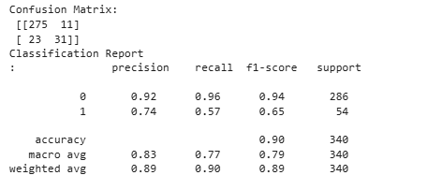
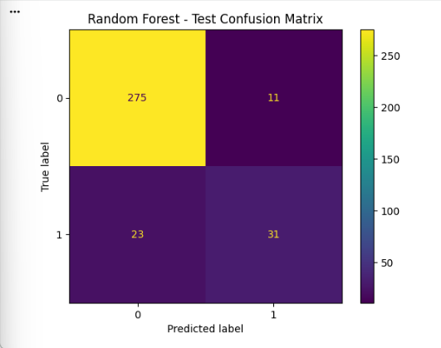
  - By comparing the results from our Random Forest and Post-Pruned Decision Tree models, it suggests that while both models achieve similar overall accuracy (~89-90%), the Random Forest model demonstrates a more balanced approach to minority class detection, whereas the Post-Pruned Decision Tree exhibits extreme conservatism, prioritizing high precision at the cost of significantly omitting positive instances (low recall at 0.31).
  - Confusion Matrix Breakdown:
    - The model correctly identified the majority of negative instances (275).
    - The model incorrectly flagged 11 negative instances as positive and missed 23 actual positive instances
    - It correctly identified 31 positive instances.
  - Key Findings:
    - Between these two approaches, the Random Forest manages to correctly capture 57% of high-risk MI patient
    - The model achieves a precision score of 0.74, suggesting that nearly three-quarters of its Class 1 predictions correspond to true major complication cases.
    - Overall, the performance of RF model shows that it is "willing" to make mistakes (11 False Positives) in order to catch more actual events, resulting in a moderate F1-score of 0.65 for the minority class.
Conclusion: While the Post-Pruned Decision Tree technically has high precision, it is likely under-fitting the minority class (Class 1) due to aggressive pruning. Ultimately, we determined that for our case of predicting major complications for MI patients, the Random Forest Classifier is the superior model. Out of all the models we generated, the Random Forest Model achieves the highest percentage (57%) in correctly identifying high-risk MI patients, which is crucial within a clinical setting. It provides a much more functional coverage of the dataset, capturing significantly more positive instances while maintaining acceptable accuracy.

5.2 Impact of Preprocessing
Preprocessing played a central role in shaping the performance and behavior of our models. Since the raw dataset contained high dimensionality, substantial null values, and a severe class imbalance, the models performed poorly until these issues were addressed. Several preprocessing steps were especially influential:
Median/Mode Imputation to Handling Missing Values
The original dataset contained 15,974 missing values, spread unevenly across both numerical and categorical variables. Without addressing these gaps, early models produced unstable splits and inconsistent predictions. Using median imputation for numerical variables allowed us to control the influence of outliers. Meanwhile, mode imputation preserved the structure of categorical variables, many of which held clinically important information such as patient symptoms. Once imputation was applied, model variance decreased noticeably, and downstream feature selection became more reliable.

Filtering Feature Selection Using Mutual Information
With 124 original features and no preprocessing, running a naïve model resulted in overfitting and unnecessary noise. Mutual information filtering reduced the dataset to the top 15 most informative variables, effectively removing irrelevant attributes that contributed little to predicting major or lethal complications. This step was particularly valuable for the Decision Tree model, which is highly sensitive to noisy or weak predictors. After feature selection, the pruned tree became more stable by achieving a higher overall accuracy compared to the baseline.

Addressing Class Imbalance with SMOTE
The target variable’s imbalance made it difficult for the models to detect true “major complication” cases. Before applying SMOTE, our pruned Decision Tree captured only 31% of high-risk patients. After SMOTE, recall for Class 1 increased to 43%, demonstrating that the synthetic minority samples helped the model better understand the structure of the minority class. This improvement resulted in a drop in precision, but in clinical contexts, identifying more high-risk patients is generally preferred over allowing them to be missed entirely.

Class Weight Adjustment in Random Forest
Instead of applying SMOTE in Approach 2, we relied on Random Forest’s class_weight='balanced' parameter, which automatically increases the influence of minority-class errors during training. This adjustment enabled Random Forest to detect 57% of high-risk cases significantly outperforming both Decision Trees from Approach 1.
Summary
Ultimately, preprocessing was not an optional step because it was a fundamental requirement for producing clinically meaningful predictions. The improvements in accuracy, recall, and overall model stability can be directly attributed to handling missing values correctly, reducing dimensionality, and addressing class imbalance. These steps produced models that were more consistent and far better aligned with the ultimate goal of identifying high-risk MI patients early in their hospital stay.

6. Learnings, Interpretation, and Recommendations

6(a) What We Learned About Data Mining
This project highlighted several practical lessons about working with real-world healthcare data:
- Data quality often matters more than model choice.
  - Much of our performance improvement came not from switching algorithms but from cleansing the data, reducing noise, and addressing imbalance.
- Ignoring class imbalance leads to misleadingly high accuracy.
  - As evidenced by our baseline model, a simple decision tree, it looked acceptable based on accuracy alone, yet it failed to detect a majority of high-risk cases. This reinforced the importance of utilizing metrics such as recall, precision, and F1-score when classes are unevenly distributed.
- Precision–recall trade-offs must reflect real-world risks.
  - During a majority of research, a created multiple models that reached accuracies higher than 85%. However, achieving extremely high precision at the expense of recall is dangerous in medical applications, where missed detections can have severe consequences.

6(b) Business Interpretation and Managerial Implications
If implemented in a clinical setting, the findings from this project could meaningfully assist hospitals in making operational decisions:

Improved Resource Allocation
Our Random Forest model identifies more than half of high-risk MI cases at admission. This gives hospitals the ability to prioritize ICU beds, continuous cardiac monitoring, and specialist intervention for the right patients. Early identification reduces delays in care and can lower the rate of sudden deterioration.

Reduction of Costly Complications
High-risk MI events often lead to extended ICU stays, emergency interventions, and greater use of staff time. By correctly classifying these patients earlier, hospitals can prevent severe downstream operational complications, which translates into:
- lower treatment costs
- reduced readmission penalties
- improved survival outcomes

Acceptable Rate of False Negatives
The Random Forest generated 11 false negatives (patients incorrectly identified as low-risk). From a business operations standpoint, this is a manageable cost, particularly compared to the risk of missing true low-risk patients.

6(c) Additional Recommendations
- Expand the dataset with more clinically relevant variables.
  - The predictive power of the model could improve substantially if we had access to detailed lab reports on patients.
- Validate the model on external hospital datasets.
  - Since the original dataset comes from a single region in Russia, obtaining additional datasets would help ensure that the model generalizes across different populations and healthcare systems.
- Explore additional algorithms that deal with imbalance
  - For the scope of this course we only used machine learning methods shown in our project, but there are other algorithms that outperform Random Forests on structured medical data and include advanced imbalance-handling techniques.
- Collaborate with clinicians to calibrate risk thresholds.
  - Having input from administrators and cardiology staff may give us better criterias to work on, and a more aggressive detection threshold depending on resource availability and hospital policies.

References:
MI article:https://www.ahajournals.org/doi/10.1161/JAHA.119.013542

Source of Dataset: https://archive.ics.uci.edu/dataset/579/myocardial+infarction+complications

Source of Dataset (same): https://figshare.le.ac.uk/articles/dataset/Myocardial_infarction_complications_Database/12045261

